MODULE -3 (Core PHP)

Q-1) Write a PHP program to enter marks of five subjects Physics, Chemistry, Biology, Mathematics and Computer, calculate percentage and grade by if else.

Ans-1)

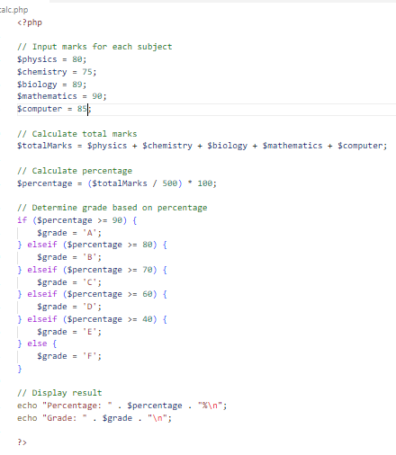

Output:



Q-2) write a PHP program for find „Thursday‟ in week using switch Function.

Ans-2)

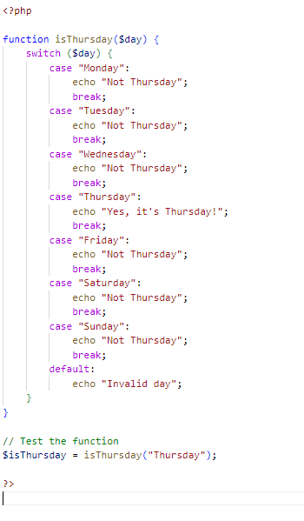

Output:



Q-3) Write a PHP program to check Leap years between 1901 to 2016 Using nested if.

Ans-3)

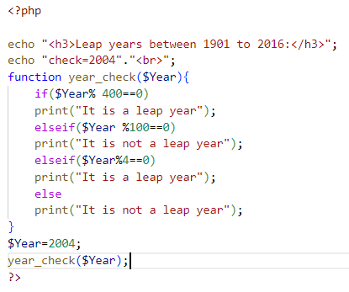

Output:

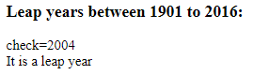

Q-4) Write a PHP program to find the largest of three numbers using ternary Operator.

Ans-4)

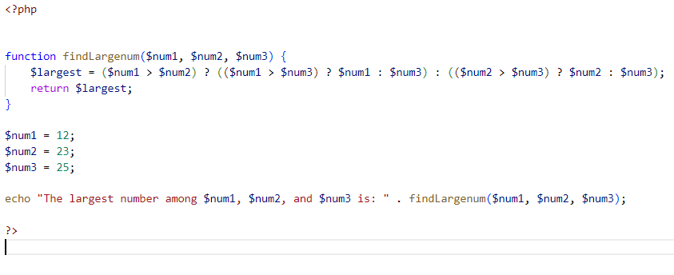

Output:



Q-5) Write a program in PHP to print Fibonacci series. 0, 1, 1, 2, 3, 5, 8, 13, 21, o 34.

Ans-5)

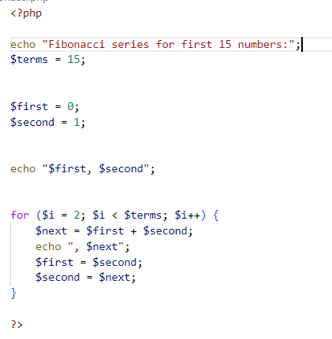

Output:



Q-6) Write a program to find whether a number is Armstrong or not Write a program to print the below format : 5 9 2610 3711 4812

Ans-6)

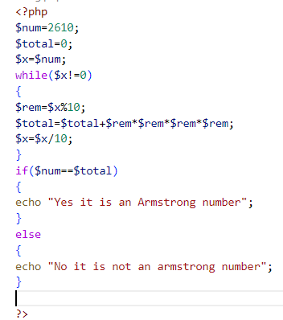

Output:



Q-7) Write a program for this Pattern:

\*\*\*\*\*

\*

\*

\*

\*\*\*\*\*

Ans-7)

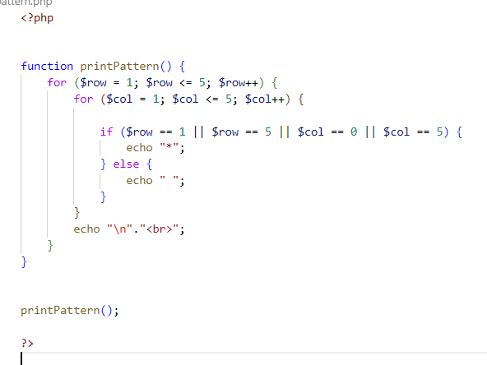

Output:

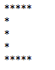

Q-8) What will be the values of $a and $b after the code below is executed?

Explain your answer. $a = '1'; $b = &$a; $b = "2$b";

Ans-8)

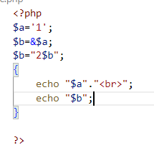

Output:



Here, a and b memory location same and b modify concatenation so answer is a and b same.

Q-9) How can you tell if a number is even or odd without using any Condition or loop?

Ans-9)

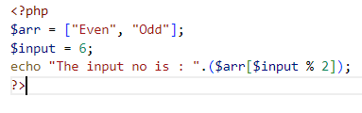

Output:



Q-10) How can you declare the array (all type) in PHP? Explain with example Covert a JSON string to array.

Ans-10)

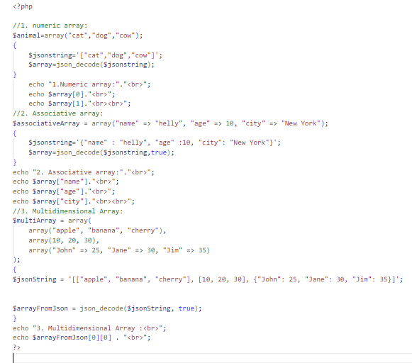

Output:

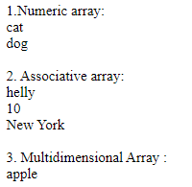

Q-11) Write program to remove duplicate values from array.

Ans-11)

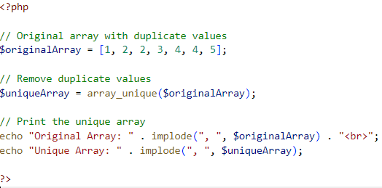

Output:



Q-12)Get random values from array.

Ans-12)

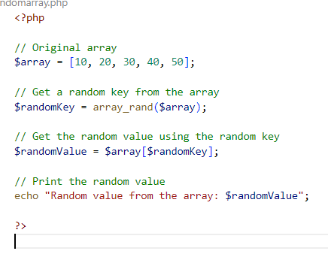

Output:



Q-13) Write a PHP script which decodes the following JSON string.

Ans-13)

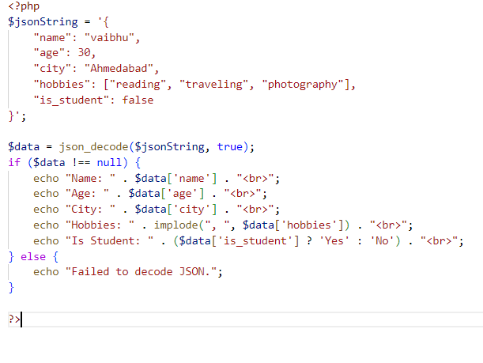

Output:

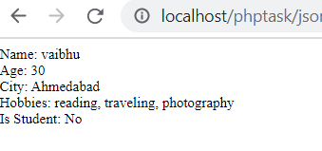

Q-14) Use a for loop to total the contents of an integer array called numbers which has five elements. Store the result in an integer called total.

Ans-14)

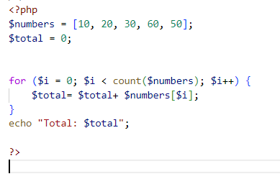

Output:



Q-15) Declare a Multi Dimensioned array of floats called balances having Three rows and five columns.

Ans-15)

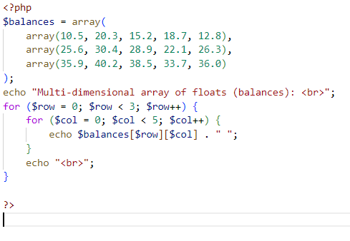

Output:

